# Lab: Remote Databases

Problems for in-class lab for the "[JavaScript Applications" course @ SoftUni](https://softuni.bg/courses/js-applications)

**1. Firebase: All Books**

Firebase is a **mobile** and **web application** development **platform**.

Create a "**TestApp**" and then create the **following** structure:

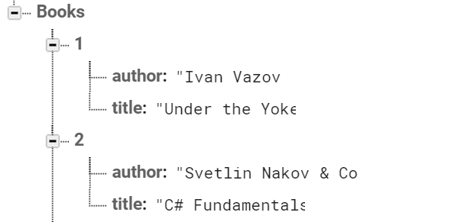

First task is to "**GET**" all books. To consume the request with **POSTMAN** your **url** should be the **following**: https://{databaseId}.firebaseio.com/.json.

**DatabaseId** is unique for every application. You can **find** yours from here:

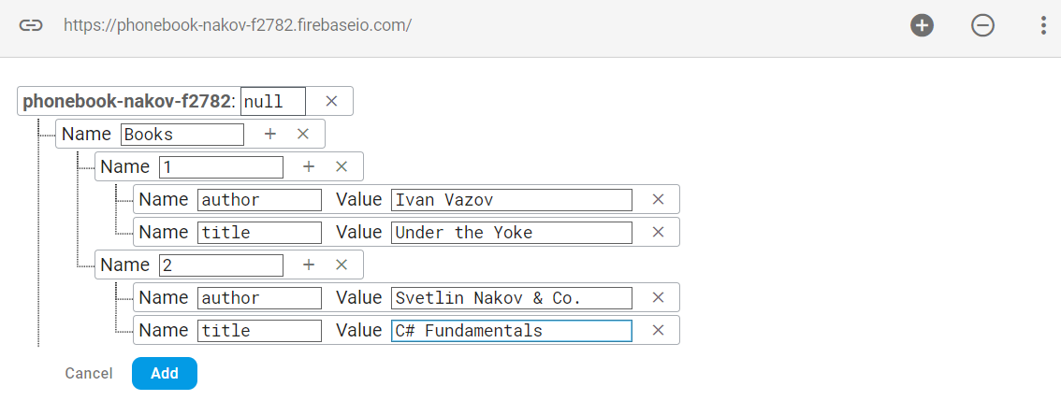

We **should** also do one more configuration. Go to Database/Rules and set **.read** & **.write** actions to "**true**". This will allow us to **send** request with **POSTMAN**. Beware that now everyone can **manipulate** our database and even **delete** it. (this is for **testing** purposes only).

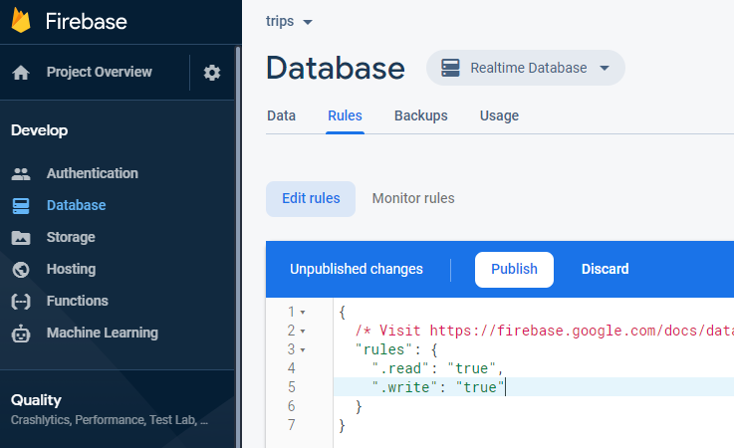

**2. Firebase: Get Book**

"**GET**" the Book with **id**: 1. Don’t forget the **.json** extension at the end (otherwise you will receive the whole **html**).

**3. Firebase: Create Book**

To **create** a book, we will have to send a "**POST**" request and the JSON body should be in the **following** format:

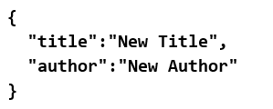

**4. Firebase: Patch Book**

The HTTP command "**PATCH**" **modifies** an existing HTTP **resource** (it can also create the resource if it does **not** exist). The JSON body should be in the **following** format:

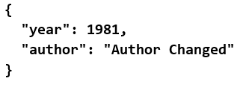

**5. Firebase: Change Book Author**

The next task is to execute a "**PUT**" command (the difference is that with "**PUT"** we can update a resource **partially**). In our case we have to **change** the author’s name to "**New author was assigned**".

**REQUEST**: https://{databaseId}.firebaseio.com/Books/7/author/.json

The JSON body should be in the **following** format:

"**New author was assigned**".